**COAL LAB**

**SUBMITTED TO: Ma’am Ayesha**

**SUBMITTED BY: ROSHNI RAZA**

**Sap id : 61278**

**BSSE 3 Lab 07**

**Task no 1**

.model small

.stack 100h

.data

.code

main proc

mov ah, 01h

int 21h

sub al, '0'

mov bl, al

mul bl ; AL * BL => AX = num^2 (square)

add al, '0'

mov dl, al

mov ah, 02h

int 21h

mov ah, 4Ch

int 21h

main endp

end main

**output**

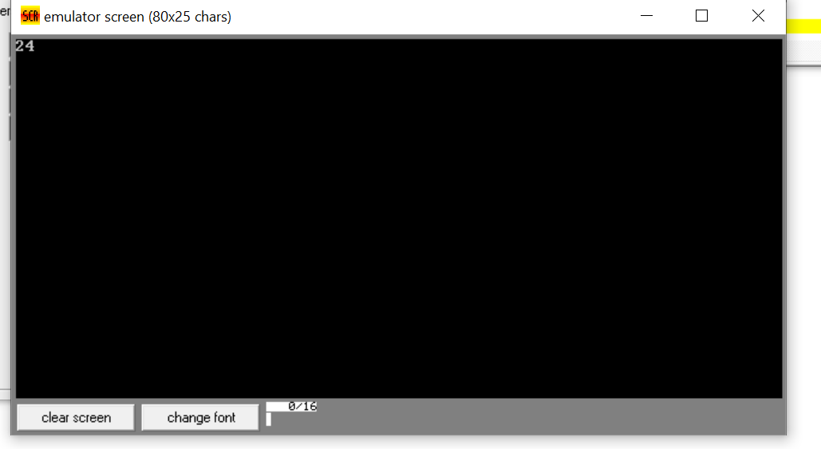

**Task no 2**

.model small

.stack 100h

.data

.code

main proc

mov ah, 01h

int 21h

sub al, '4'

mov bl, al

; Input Height

mov ah, 01h

int 21h

sub al, '5'

mov dl, bl

mul al

mov bx, 2

div bx

add al, '0'

mov dl, al

mov ah, 02h

int 21h

mov ah, 4Ch

int 21h

main endp

end main

**output**

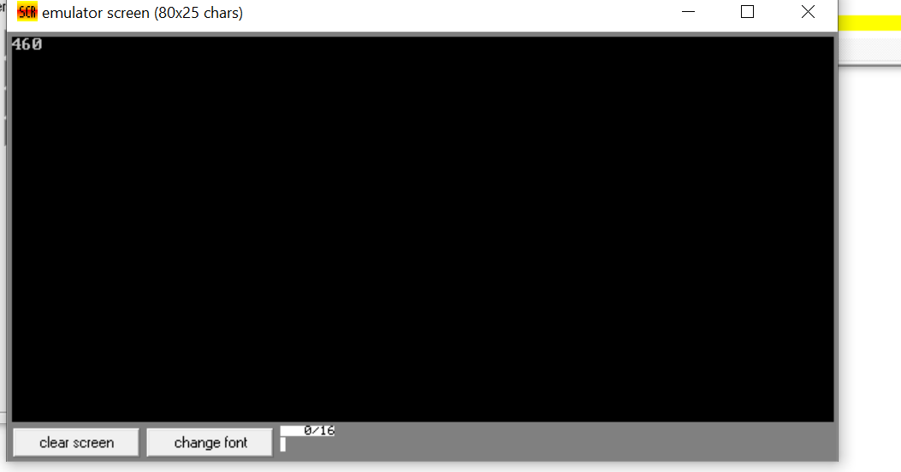

**Task no 3**

**.**model small

.stack 100h

.data

.code

main proc

mov ah, 01h

int 21h

sub al, '0'

mov bl, al

mov ah, 01h

int 21h

sub al, '0'

mul bl

add al, '0'

mov dl, al

mov ah, 02h

int 21h

mov ah, 4Ch

int 21h

main endp

end main

**output**

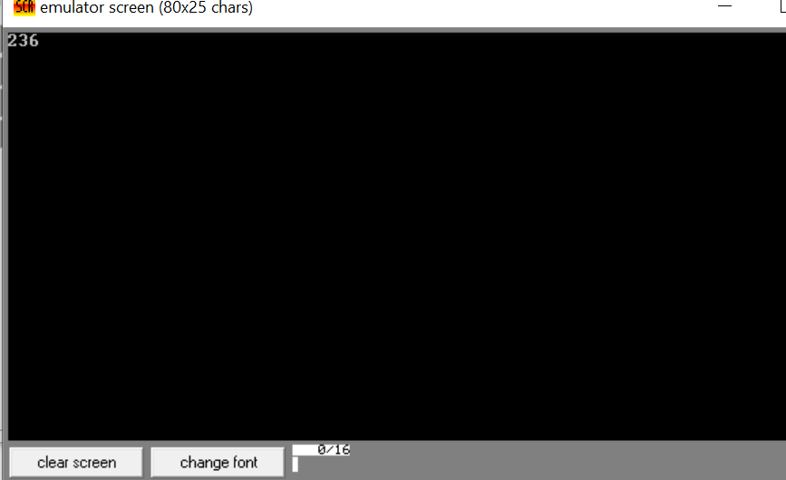

**Task no 3**

.model small

.stack 100h

.code

main proc

; Read number

mov ah, 01h

int 21h

sub al, '0'

mov bl, al

; Calculate cube

mov al, bl

mul bl

mul bl

; Print result (handling numbers greater than 9)

mov cx, ax

mov ah, 02h

mov dl, ch

add dl, '0'

int 21h

mov dl, cl

add dl, '0'

int 21h

; Exit

mov ah, 4ch

int 21h

main endp

end main

**output**

